WEB BASICS – HTML5 LAB BOOK

Web Basics – HTML5

Lab Book

WEB BASICS – HTML5 LAB
WEB BASICS – HTML5 LAB BOOK

Table of Contents

Getting Started 5

Overview 5

Setup Checklist for HTML5 5

Minimum System Requirements 5

Please ensure that the following is done: 5

Instructions 5

Learning More (Bibliography) 5

Lab 1: HTML Basics 7

1.1: Create HTML Page 7

1.2 Example: MyFirstPage.html 8

1.3 Example: Headers.html 9

1.4 Example: Address.html 10

1.5 Example: PreFormattedText.html 11

Lab 2: Creating Tables 15

Problem 1: Fun with Food 15

Problem 2: Table Heading << To Do>> 18

Problem 3: Calendar <<To Do>> 18

Lab 3: Working with Lists 20

Problem 1: Types of Lists 20

Problem 2: Subjects <<To Do>> 22

Lab 4: Working with Links 23

Problem 1: Welcome to Big Company 23

Problem 2: Employee Details <<To Do>> 28

Lab 5: Image Handling 29

Problem 1: Images with Clickable Areas <<To do>> 29

Lab 6: Working with Frames 31

Problem 1: Frames 31

Lab 7: HTML Forms for User Input 36

Problem 1: Form 36

Problem 2: Employee Details <<To Do>> 38

Lab 8: New Form Elements 40

WEB BASICS – HTML5 LAB BOOK

Problem 1: Form 40

Problem 2: Candidate Details <<To Do>> 46

Appendices 48

Appendix A: HTML Standards 48

Appendix B: Table of Figures 52

Appendix C: Table of Examples 53

WEB BASICS – HTML5 LAB BOOK

Getting Started

Overview

This lab book is a guided tour for learning HTML. It comprises solved examples and ‘To Do’ assignments. Follow the steps provided in the solved examples and work out the ‘To Do’ assignments given.

Setup Checklist for HTML5

Here is what is expected on your machine in order for the lab to work.

Minimum System Requirements

Intel Pentium 90 or higher (P166 recommended) Microsoft Windows 95, 98, or NT 4.0, 2k, XP.
Memory: 32MB of RAM (64MB or more recommended) Internet Explorer 6.0 or higher

Please ensure that the following is done:

A editor like Notepad, Eclipse, Visual Studio 2008 is installed.

Instructions

For all coding standards refer Appendix A. All lab assignments should refer coding standards.

Create a directory by your name in drive <drive>. In this directory, create a subdirectory html_assgn. For each lab exercise create a directory as lab <lab number>.
You may also look up the on-line help provided in the MSDN library. The faculty will introduce you to the editor to be used.

Learning More (Bibliography)

HTML Source Book by Ian S. Graham

HTML: Complete Concepts and Techniques by Gary B. Shelly

HTML: The Definitive Guide by Chuck Musciano

EB BASICS – HTML5 LAB BOOK

Dynamic HTML: The Definitive Reference by Danny Goodman

HTML: The Complete Reference by Thomas A. Powell

WEB BASICS – HTML5 LAB BOOK

Lab 1: |  | HTML Basics
 |  |  | Understand the process of creating an HTML page and viewing it in a
 | Goals |  | browser window.
 | Goals |  | Learn to apply physical or logical character effects.
 |  |  | Learn to manage document spacing
 | Time |  | 45 minutes

1.1: Create HTML Page

Create a web page to display the text ‘This is the first html page created’.

Solution:

Step 1: Click the Start button. On the Programs menu, navigate to the Accessories submenu.

Click Notepad.

Step 2: Write the below HTML program in Notepad.

<!DOCTYPE html>

<html>

<head>

<title>This is the first html page</title>

</head>

<body>

This is the first html page created

</body>

</html>

Step 3: Save the file with extension .html. Save it in the lab1 directory as firstpage.html.

Step 4: From Internet Explorer, on the File menu, click Open. Open dialog box appears. Click Browse to select the file you have just saved. Refer to the figure that follows.
Step 5: Once you have selected the file, click OK in the Open dialog box. Output appears as shown in the figure that follows.

WEB BASICS – HTML5 LAB BOOK
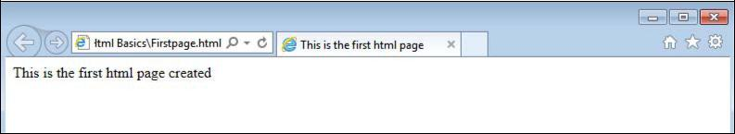

Figure 1: First.html in a browser

1.2 Example: MyFirstPage.html

<!DOCTYPE html>

<html>

<head>

<title>My First Page</title>

<meta [http‐equiv] [contents=n]>

<meta http‐equiv=refresh content=60>

<!‐‐‐will refresh the current document after every 60 seconds.‐‐> <meta http‐equiv=refresh content=”20;url=c:/html/html34.htm”> <‐‐will load secified file after 20 seconds. → <base href=“c:/mydir/html/”>

<!‐‐ you to use shortcuts in your URLs if you must reference several files from the same

location.‐‐>

</head>

<body> Hello World!! </body>

</html>

Example 1: MyFirstPage.html

Output of the above HTML code is:

WEB BASICS – HTML5 LAB BOOK
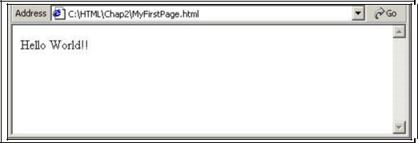

Figure 2: MyFirstPage.html Output

1.3 Example: Headers.html

<!DOCTYPE html>

<html>

<head><title>This is the first html page</title>

<body>This is the first html page created

<h1>This is level 1 heading</h1>

<h2>This is level 2 heading</h2>

<h3>This is level 3 heading</h3>

</body>

</head></html>

Example 2: Headers.html

WEB BASICS – HTML5 LAB BOOK
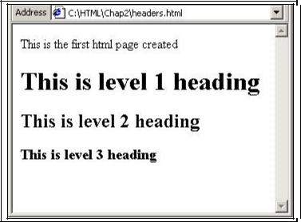

Figure 3: Headers.html Output

1.4 Example: Address.html

<html>

<head>

<title>Address Example</title>

</head>

<body>

<font size="2">Your address:</font><br>

Abc Xyz<br>

<address>b/102 royal palms,</address>

<address>off. s. v. road,</address>

<address>Andheri-West,</address><address>Mumbai.</address>

</body>

</html>

Example 3: Address.html

WEB BASICS – HTML5 LAB BOOK
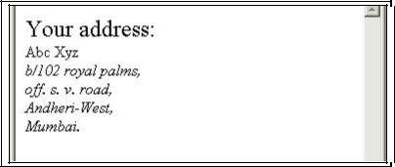

Figure 4: Address.html Output

1.5 Example: PreFormattedText.html

WEB BASICS – HTML5 LAB BOOK

<!DOCTYPE html>

<html>

<head><title>

PREFORMATTED TEXT EXAMPLE

</title></head>

<body>

<h3>GROSS SALE WITH PREFORMATTING</h3>

<hr>

<pre>

 | <b>GROSS SALES</b>
SALESMAN | SALES | RANKING
TIM | $10,000 | 2<BR>
TOM | $ 5,000 | 5<BR>
TAMMY | $20,000 | 1<BR>

Each line has a carriage return after it.

</pre>

<h3>GROSS SALE WITHOUT PREFORMATTING</h3> <p><hr>
 | <b>GROSS SALE<b>
SALESMAN | SALES | RANKING
TIM | $10,000 | 2<BR>
TOM | $ 5,000 | 5<BR>
TAMMY | $20,000 | 1<BR>
</body>

Example 4: PreFormattedText.html

WEB BASICS – HTML5 LAB BOOK
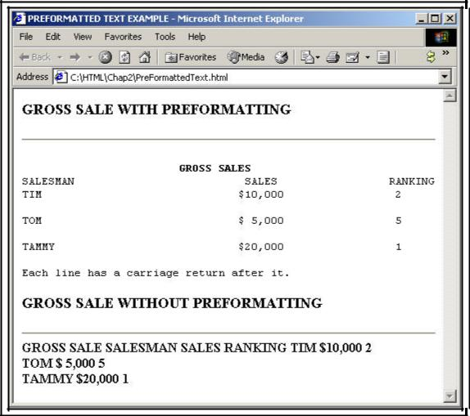

Figure 5: PreFormattedText.html Output

Problem 1: Resume Creation <<To Do>>

Problem Statement:

Create your resume page as per the format shown in the figure that follows.

WEB BASICS – HTML5 LAB BOOK
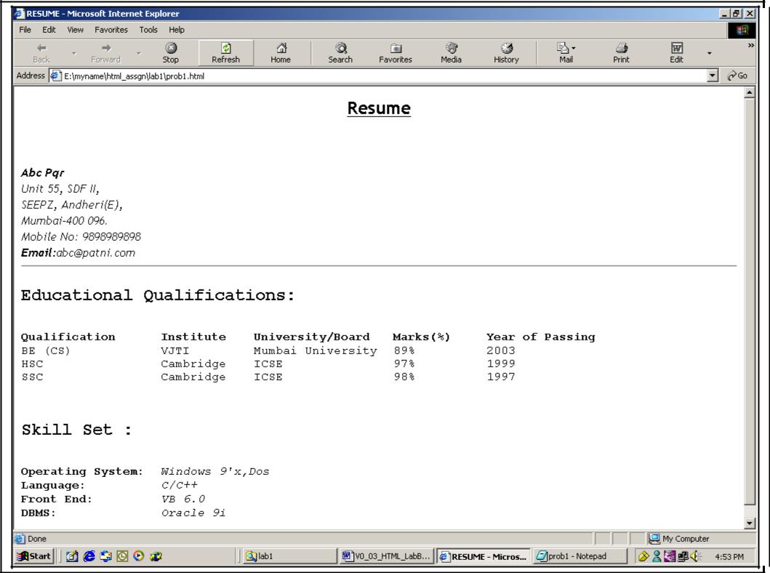

Figure 6: Resume Page

Solution:

- Open Editor. Type the code and save the file.

- Use Heading 2 for the headings “Educational Qualifications” and “Skill Set”.

- Use font size 3 for data pertaining to educational qualifications and skill set.

- Display details against categories under Skill Set in italics.

- Start the Internet Explorer. On the File menu, click Open. File open dialog box appears. Click the Browse button and select prob2.html file.
- Check if the output is as per the requirement.

WEB BASICS – HTML5 LAB BOOK

Lab 2: |  | Creating Tables
 |  |  | At the end of this lab session you will understand:
 |  |  | Attributes of a Table
 |  |  |  | Table Headers
 | Goals |  |  | Table Data
 |  |  |  | Table Formatting
 |  |  |  | Control Table Borders
 |  |  |  | Grouping of Columns
 | Time |  | 90 minutes

Problem 1: Fun with Food

Problem Statement:

Create a web page, which uses a table with columns Fruit, Color and Cost per pound as shown in the figure that follows.
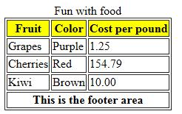

Figure 7: Fruits Table

Solution

Step 1: Write the following code in Notepad and save the file.

WEB BASICS – HTML5 LAB BOOK

<! DOCTYPE html>

<html>

<head>

<title>Fruits Table</title>

</head>

<body>

<table border="1" >

<caption>Fun with food</caption>

<colgroup>

<col>

</colgroup>

<colgroup>

<col align="center">

<col>

</colgroup>

<thead>

<tr>

<th style="background‐color:yellow">Fruit</th>

<th style="background‐color:yellow">Color</th>

<th style="background‐color:yellow">Cost per pound</th>

</tr>

</thead>

<tbody>

<tr>

<td>Grapes</td>

<td>Purple</td>

<td>1.25</td>

</tr>

<tr>

<td>Cherries</td>

WEB BASICS – HTML5 LAB BOOK

<td>Red</td>

<td>154.79</td>

</tr>

<tr>

<td>Kiwi</td>

<td>Brown</td>

<td>10.00</td>

</tr>

</tbody>

<tfoot>

<tr>

<th colspan="3">This is the footer area</th>

</tr>

</tfoot>

</table>

</body>

</html>

Example 5: Fruit Table

Step 2: Open the file page in the browser to check the required output.

WEB BASICS – HTML5 LAB BOOK

Problem 2: Table Heading << To Do>>

Problem Statement: Create a html page. When this page is opened in a browser, it should appear as shown in the following figure
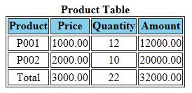

Figure 8: Product table

Note: Table heading - Background color is: navy and font color is: white.

Solution

- Open Editor. Type the code and save the file.

- Open the page in browser

- Check the page shown in the browser and verify that it is as per the requirement.

Problem 3: Calendar <<To Do>>

Problem Statement:

Design a web page to display a calendar for a month using html table.
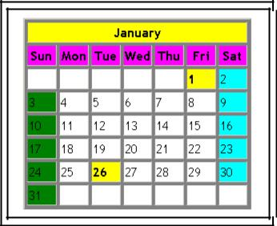

Figure 9: Calendar

Note: Background colors to be used: For all the Sundays: green, for all the Saturdays:

aqua, for 1, 26 Jan: yellow

WEB BASICS – HTML5 LAB BOOK

Solution

- Open Notepad. Type the code and save the file.

- Open the page in browser.

- Verify that the output is as per requirements.

WEB BASICS – HTML5 LAB BOOK

Lab 3: |  |  | Working with Lists
 |  |  |  |  | At the end of this lab session you will be able to use following types of lists:
 |  |  |  |  |  | Numbered List
 |  | Goals |  |  |  | Bulleted List
 |  |  |  |  |  | Directory List
 |  |  |  |  |  | Glossary List
 |  |  |  |  | 30 minutes
 |  | Time

Problem 1: Types of Lists

Problem Statement:

Design a web page as shown below
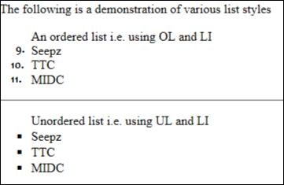

Figure 10: List

WEB BASICS – HTML5 LAB BOOK

Solution

Step 1: Write the following code in Notepad and save.

<!DOCTYPE html>

<html>

<head>

<title>Working with Lists</title>

</head>

<body>

<p>The following is a demonstration of various list styles <ol start="3">
An ordered list i.e. using OL and LI

<li>Seepz

<li value="10">TTC

<li>MIDC

</ol>

<hr>

<ul style="list-style-type: square">

Unordered list i.e. using UL and LI

<li>Seepz

<li>TTC

<li>MIDC

</ul>

</body>

</html>

Example 6: Types of Lists

Step 2: Check the page shown in the browser and verify that it is as per the requirement.

WEB BASICS – HTML5 LAB BOOK

Problem 2: Subjects <<To Do>>

Create a web page to display a list as shown in the figure that follows.

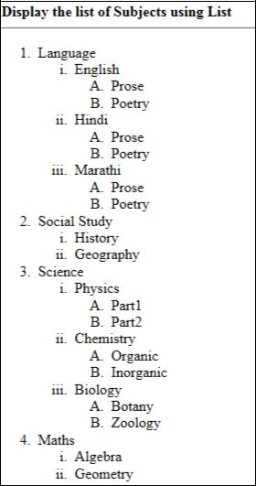

WEB BASICS – HTML5 LAB BOOK

Lab 4: Working with Links

 | At the end of this lab session you will be able to:
 | Create links to web documents.
Goals | Create links to email.
 | Create hyperlinks for lists and table data.
 | Provide target for hyperlink.
Time | 30 minutes

Problem 1: Welcome to Big Company

Problem Statement:

Design a simple home page for a company with a heading and 3 links – About, Products, Contact as given in the figure below.
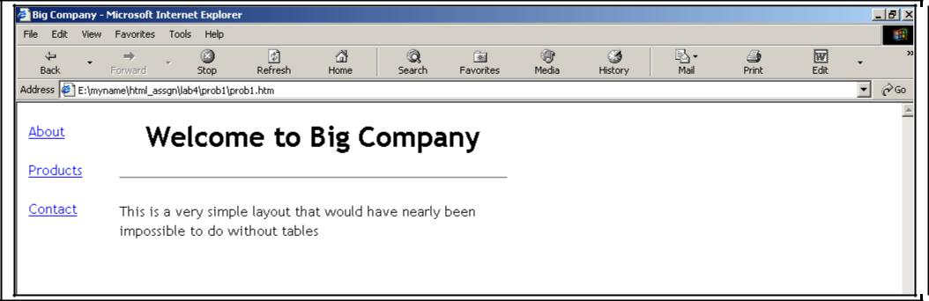

Figure 12: Big Company home page

WEB BASICS – HTML5 LAB BOOK

When you click the “About” hyperlink, following page should be displayed.
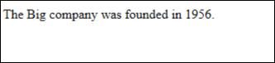

Figure 13: About

When you click the Back button on the browser toolbar, they should be redirected to the page prob1.html. Click the “Products” hyperlink to reach the following page:
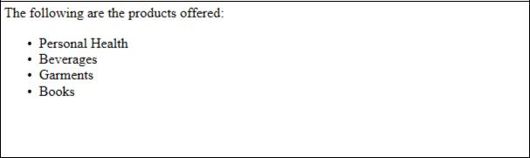

Figure 14: Products

When you click the Back button on the browser toolbar, they are redirected to page prob1.html. Click the “Contact” hyperlink. It opens Outlook Express and the e-mail address given in the To field, which is lnd.in@mphasii.com in the following illustration, is displayed in the New message window. This email address is specified in the mailto attribute.
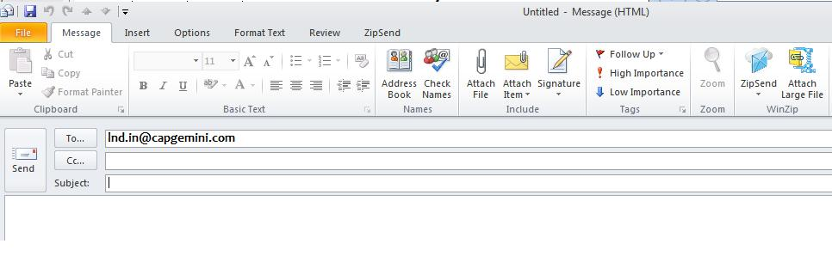

Figure 15: Contact

WEB BASICS – HTML5 LAB BOOK

Solution

Step 1: Write the following code in Notepad and save the file.

<!DOCTYPE html>

<html>

<head>

<title>Big Company</title>

</head>

<body>

The Big company was founded in 1956.

</body>

</html>

Example 7: Big Company

WEB BASICS – HTML5 LAB BOOK

Step 2: Write the following code in Notepad and save it as the file.

<!DOCTYPE html>

<html>

<head>

<title>Products</title>

</head>

<body>

The following are the products offered :

<ul>

<li>Personal Health </li>

<li>Beverages </li>

<li>Garments </li>

<li>Books </li>

</ul>

</body>

</html>

Example 8: Products

WEB BASICS – HTML5 LAB BOOK

Step 3: Write the following code in Notepad and save the file.

<!DOCTYPE html>

<html>

<body>

<table>

<tr>

<td>

<a href="about.htm">About</a><br><br>

<a href="products.htm">Products</a><br><br>

<a href="mailto:lnd@mphasis.com">Contact</a><br><br>

</td>

<td>

<h1>Welcome to Big Company</h1>

<hr>

<p>This is a very simple layout that would have nearly been impossible to do without tables</p>
</td>

<td><br></td>

</tr>

</table>

</body>

</html>

Example 9: Welcome to Big Company

Step 4: Start the Internet Explorer. On the File menu, click Open. Open dialog box appears. Click the Browse button and open the page with links file. Verify if the links on the page are working as per the requirement.

WEB BASICS – HTML5 LAB BOOK

Problem 2: Employee Details <<To Do>>

Problem Statement:

Design a simple home page for a company to display employee details as given below.
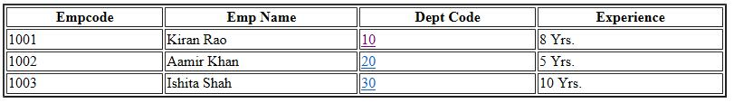

Figure 16: EmployeeDetails

When you click the department code “10” hyperlink, page with following content should be displayed.

This is Sales department located at Mumbai...

Figure 17: Sales Department

When you click the department code “20” hyperlink, page with following content should be displayed.

This is training department located at Pune...

Figure 18: Training Department

When you click the department code “30” hyperlink, page with following content should be displayed.

This is accounts department located at Chennai...

Figure 19: Accounts Department

WEB BASICS – HTML5 LAB BOOK

Lab 5: Image Handling

 | At the end of this lab session you will be able to:
 |  | Understand the use of inline images.
Goals |  | Attributes of an inline image.

Text and image aligning.

Use of an image as a hyperlink.

Time30 minutes

Problem 1: Images with Clickable Areas <<To do>>

Problem Statement:

Create a web page with some images as shown in following figure:

WEB BASICS – HTML5 LAB BOOK
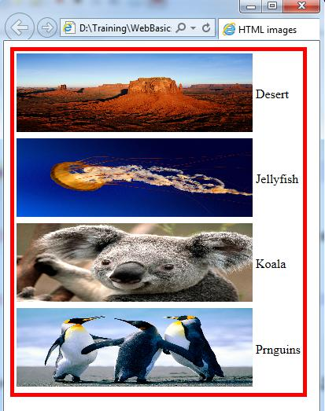

Figure 20 : Images

WEB BASICS – HTML5 LAB BOOK

Lab 6: Working with Frames

At the end of this lab session you will be able to:

Understand the need for frames in web pages.
Goals

Create and work with frames.

Manage large content with frame.

Time 30 minutes

Problem 1: Frames

Problem Statement:

Create a web page which allows you to click on 2 hyperlinks courses, menu in the frame on the left. When you click a link, the details are displayed in the frame on the right. The file layout.html is loaded in the frame on the left.
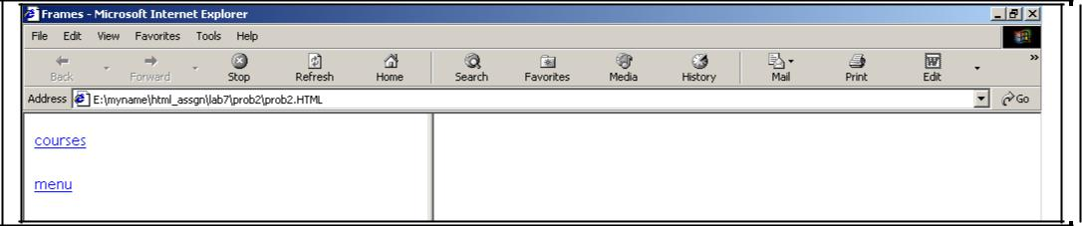

Figure 211: Frames

When you click the link “courses”, the details are displayed in the frame on the right.

WEB BASICS – HTML5 LAB BOOK
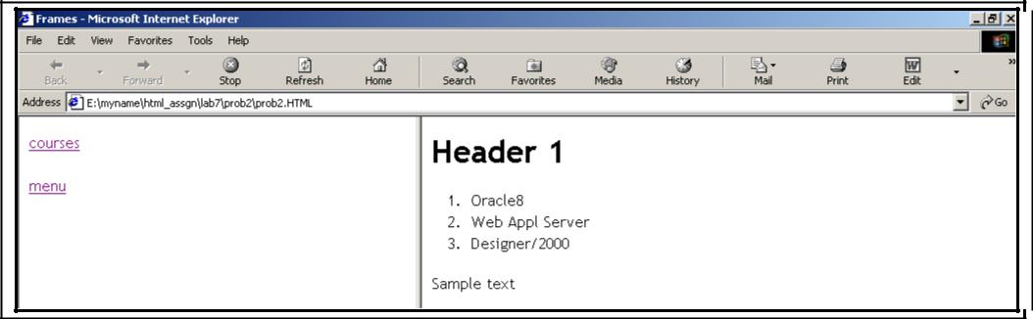

Figure 222: Courses

When you click the link “menu”, the details are displayed in the frame on the right
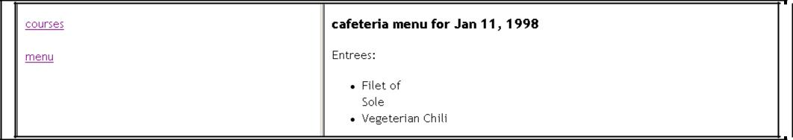

Figure 233: Menu

WEB BASICS – HTML5 LAB BOOK

Solution

Step 1: Write the following code in Notepad and save the file.

<!DOCTYPE html>

<html>

<head>

<title>Frames</title>

</head>

<body>

<iframe src="content.html" width="100"></iframe>

<iframe name="side-2" width="1000"></iframe>

</body>

</html>

Example 10: Frames (1)

Step 2: Write the following code in Notepad and save it as lab6\prob1\layout.html.

<!DOCTYPE html>

<html>

<body>

<a href="courses.html" target="side-2"> courses </a><br><br> <a href="menu.html" target="side-2"> menu </a> </body>

</html>

Example 11: Frames (2)

WEB BASICS – HTML5 LAB BOOK

Step 3: Write the following code in Notepad and save.

<html>

<head>

<title>Sample Page</title>

</head>

<body >

<h1>Header 1</h1>

<ol>

<li>Oracle8</li>

<li>Web Appl Server</li>

<li>Designer/2000</li>

</ol>

Sample text

</body>

</html>

Example 12: Courses

WEB BASICS – HTML5 LAB BOOK

Step 4: Write the following code in Notepad and save.

<html>

<head>

<title>Cafeteria Menu Application</title>

</head>

<body>

<h3>cafeteria menu for Jan 11, 1998</h3>

<p>

Entrees:<br>

<ul>

<li>Filet of <br>Sole

<li>Vegeterian Chili

</ul>

</body>

</html>

Example 13: Menu

Step 5: Open the file prob1\layout.html in the browser and check if the page works as per the requirement.

WEB BASICS – HTML5 LAB BOOK

Lab 7: HTML Forms for User Input

 |  | At the end of this lab session you will be able to:
 |  | Understand the role of forms in web pages.
 | Goals | Understand the role of forms in web pages.
 | Goals | Understand various HTML elements used in forms.
 |  | Develop HTML forms in web pages.

Time 45 minutes

Problem 1: Form

Problem Statement:

Design a web page prob1.html in the directory lab7. When prob1.html is opened in the browser, the page is displayed as shown in the figure that follows.
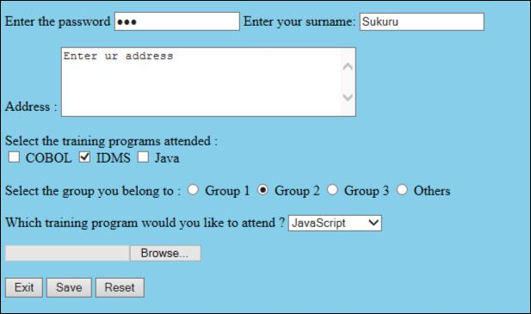

Figure 244: Forms

WEB BASICS – HTML5 LAB BOOK

Solution

Step 1: Write the following code in Notepad and save it as lab6\prob1.html.

<!DOCTYPE html>

<html>

<head>

<title>Form Methods</title>

</head>

<body style="background-color:skyblue">

<form action="mailto:lnd.in@mphasis.com" name="ab" method="post"

enctype="multipart/form-data">

<p>

Enter the password

<input type="password"name="USERNAME" size="20" value="abc" tabindex="3"> <input type="hidden" name="coname" value="PCS"> Enter your surname:

<input type="text" name="surname" SIZE="20" readonly value="Sukuru" tabindex="2"

maxlength="30"> <br> <br>

Address :

<textarea name="addr" Rows="5" cols="40" tabindex="0" accesskey="A">Enter ur address </textarea>
<br> <br> Select the training programs attended : <br> <input type="checkbox" name="s-cobol"> COBOL <input type="checkbox" name="s-idms" checked> IDMS <input type="checkbox" name="s-java"> Java <br> <br> Select the group you belong to :

<input type="radio" name="s-grp" value="grp1"> Group 1

<input type="radio" name="s-grp" value="grp2" checked> Group 2 <input type="radio" name="s-grp" value="grp3"> Group 3
<input type="radio" name="s-grp" value="oth"> Others <BR> <BR> Which training program would you like to attend ? <select name="pref">

WEB BASICS – HTML5 LAB BOOK

<option value="JS">JavaScript </option>

<option value="CORBA">CORBA </option>

<option value="VB6">Visual Basic 6 </option>

</select>

</p>

<input type="file" name="fnm"> <br><br>

<input type="button" name="but" value="Exit">

<input type="Submit" Value="Save" name="s-but">

<input type="reset" Value="Reset">

</form>

</body>

</html>

Example 14: Forms

Step 2: Open prob1.html in the browser and verify if the form is displayed as per the requirement.

Problem 2: Employee Details <<To Do>>

Problem Statement:

Design a web page prob2.html to accept the following employee details:

Employee Name (Max 20 characters). Employee Code (Max 4 characters). Department (Use radio buttons).

Date of Join (Use the format dd/mm/yyyy). Address.

Training programs attended (Use check boxes).

Training programs need to attend (Use select box). Send the information at empinfo@mphasis.com.

WEB BASICS – HTML5 LAB BOOK
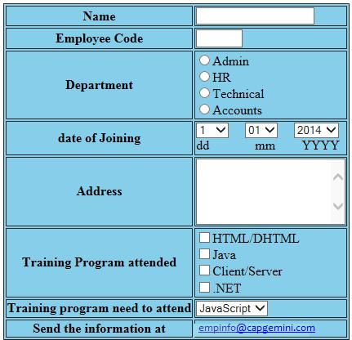

Figure 255: Employee Details

Solution

- Open Editor. Type the code and save the file as lab7\prob2.html.

- Open the page in the browser.

- Verify if the output is as per the figure.

WEB BASICS – HTML5 LAB BOOK

Lab 8: New Form Elements

At the end of this lab session, you will be able to:

Goals
Develop web pages using HTML5 enhanced form elements

Time 120 minutes

Problem 1: Form

Problem Statement:

Design a web page prob1.html in the directory lab8. When prob1.html is opened in the browser, the page is displayed as shown in the below figure

Solution

Step 1: Write the following code in Notepad and save it as lab8\prob1.html.

<! DOCTYPE html>

<html>

<head>

<meta name="viewport" content="height=device-height,width=device-width,user-scalable=no" />
<meta charset="UTF-8">

<title>New Form Elements</title>

</head>

<body>

<form name="Formelements" action="index2.jsp">

<table>

<tr>

<td><label for="demo">Placeholder : </label></td>

<td><input id ="demo" name="demo" placeholder="Enter Numbers Only" /></td> </tr>
<tr>

<td><label for="nameauto">Autofocus : </label></td>

<td><input id ="nameauto" name="nameauto" type="text" autofocus/></td> </tr>

WEB BASICS – HTML5 LAB BOOK

<tr>

<td><label for="range">Range : </label></td>

<td><input id="range" name="range" type="range" min="0" max="50" value="10"

/><td>

</tr>

<tr>

<td><label for="search">Search : </label></td>

<td><input id="search" name="search" type="search" placeholder="Search..."

/><td>

</tr>

<tr>

<td><label for="date">Date : </label></td>

<td>

<input id="date" name="date" type="date" min="2010-08-14" max="2014-08-14" value=""/></td>
</tr>

<tr>

<td><label for="date">Week : </label></td>

<td><input id="date" name="date" type="week" value=""/></td> </tr>

<tr>

<td><label for="date">Month : </label></td>

<td><input id="date" name="date" type="month" value=""/></td> </tr>

<tr>

<td><label for="date">Time : </label></td>

<td><input id="date" name="date" type="time" value=""/></td>

WEB BASICS – HTML5 LAB BOOK

</tr>

<tr>

<td><label for="number">Number : </label></td>

<td>

<input id="number" name="number" type="number" step="1" min="-5" max="10" value="0" />
<td>

</tr>

<tr>

<td><label for="required">Required : </label></td>

<td><input id="required" name="user" type="text" required /></td>

</tr>

<tr>

<td><label for="email">Email:</label></td>

<td><input id="email" name="email" type="email" required/></td> </tr>
<tr>

<td><label for="color">Color : </label></td>

<td><input id="color" name="color" type="color" placeholder="e.g. #bbbbbb"

/><td>

</tr>

<tr>

<td><label for="country_name">Country : </label></td>

<td><input id="country_name" name="country_name" type="text" list="country"

/></td>

WEB BASICS – HTML5 LAB BOOK

 | <td><datalist id="country">
 | <option value="Afghanistan">
 | <option value="Albania">
 | <option value="Algeria">
 | <option value="Andorra">
 | <option value="Angola">
 | <option value="Car">
 | <option value="Cat">
 | <option value="City">
 | <option value="Cup">
 | <option value="Clip">
 | </datalist></td>
 | </tr>
 | <tr><td colspan="2"><audio controls >
 | <source src= "god.mp3" type="audio/mpeg" />
 | <source src= "1vs0_JuniorGroove.ogg" type="audio/ogg"/>
 | </audio></td></tr>
 | <!-- audio code works on Firefox and opera .ogg format only |  | -->
 | <tr>
 | <td colspan="2"><video
 | src="http://upload.wikimedia.org/wikipedia/commons/7/79/Big_Buck_Bunny_small.ogv"
 | controls width="300" height="250">
 | </video></td></tr>
 | <!-- Video code works only on Firefox. .ogg format. various ogg file extension are
 | .ogx, .ogv, .oga, .spx. | -->
 | </table>
 | <table>
 | <tr>

WEB BASICS – HTML5 LAB BOOK

<td align="right"><button type="submit" name="submit"

value="Submit">Submit</button></td>

<td align="left"><button type="reset" name="reset"

value="reset">Reset</button></td>

</tr>

</table>

</form>

</body>

</html>

Example 155: Code for New Form Elements

WEB BASICS – HTML5 LAB BOOK
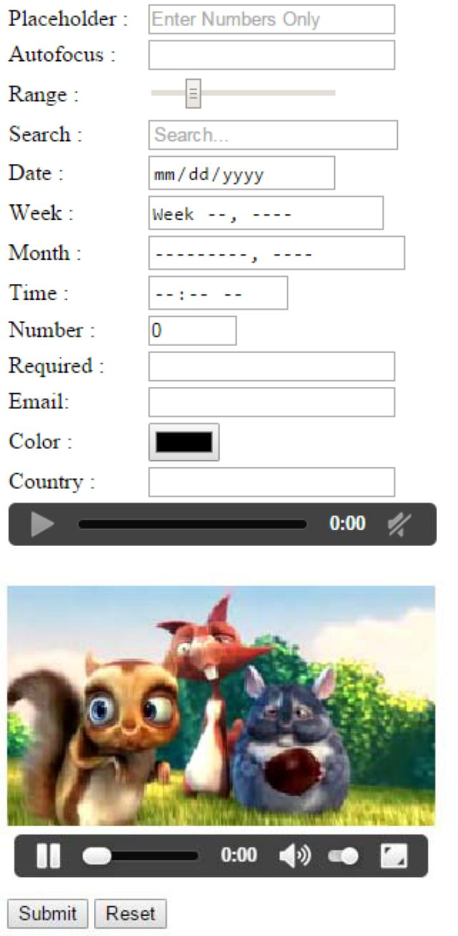

Figure 266: New Form Elements

WEB BASICS – HTML5 LAB BOOK

Problem 2: Candidate Details <<To Do>>

Problem Statement:

Design a web page StudentInfoForm.html to accept the following student details:

- Name (Accept only characters , Max 15 characters )

- Password (Max 15 characters)

- Phone number(Accept 10 digits)

- Gender (Make use of radio button)

- Date of Birth (Make use of date field and date of birth should not be greater than current date)

- Email (Accept valid Email)

- Highest Qualification (Make use of datalist to populate data like B.Tech, M.Tech, MBA, MCA, MSc, MA, BSC..)
- Courses interested in (Make use of check box)

9. Comments to mention regarding Degree / External Certificates (Make use of textarea)

- Uploading Degree / External certificates (Make use of file input type)

- Use Placeholders to describe the type of input.

- All fields marked (*) are mandatory

WEB BASICS – HTML5 LAB BOOK
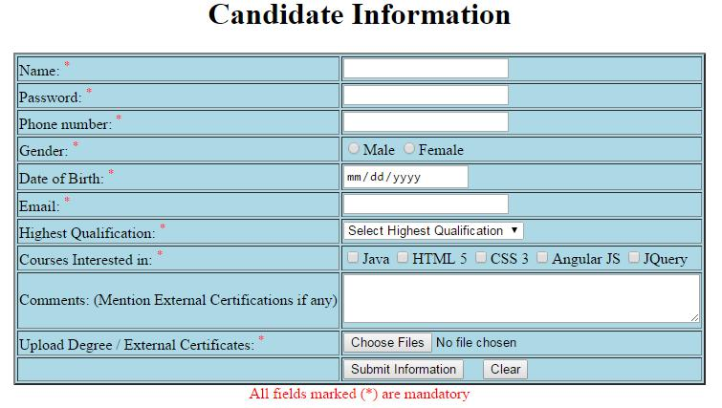

Figure 277: Candidate Details

Solution

- Open Editor. Type the code and save the file as lab7\prob2.html.

- Open the page in the browser.

- Verify if the output is as per the figure.

WEB BASICS – HTML5 LAB BOOK

Appendices

Appendix A: HTML Standards

Key Things To Keep In Mind:

HTML standards help you reach the widest possible audience.

There are many technologies that are associated with HTML because they are used on a Web page or in conjunction with HTML. But these technologies are not HTML:

o CGI (Common Gateway Interface) o Java

o JavaScript(JavaScript is also not Java) o Dynamic HTML (DHTML)

o XML ( Extensible Markup Language)

o A variety of other emerging technologies

o For each of it, please follow the coding conventions, specified by that technology. Sometimes you need to break the rules and use non-standard syntax for good reasons.

Try to keep this to a minimum.

WEB BASICS – HTML5 LAB BOOK

How to Follow HTML Standards

Identify which version of HTML you are using in your document through the DOCTYPE line at the top of your file.
See the W3C site for more information on document types and DOCTYPE statements.

The important thing to remember is that a DOCTYPE statement is essential to assist validation software in checking your document.

Use tools (supported by W3C) that support standards. In particular, install and use the Tidy program or Tidy GUI on your computer.

Use W3C validation markup service to check the syntax of documents you create. Refer to W3C for technical and syntax information.
Some Simple HTML standards:

The names of HTML files should always end with the ".html" extension. Example:
Good: foo.html

Bad: foo.bar

Always include a <HTML> tag at the very beginning and a </HTML> tag at the very end of your HTML documents.

Always use the <HEAD> and </HEAD> tags to define a header section in your HTML documents.

Always give your documents a title by using the <TITLE> and </TITLE> tags in the header section of your HTML documents.

Always use the <BODY> and </BODY> tags to define the body in your HTML documents, which is everything in your document between the <HTML> and </HTML> that is not contained in your header section.

Use the horizontal line tag <HR> to place a horizontal line beneath any prominent headers in your documents to help them stand out from the surrounding information.
Example:

<H1>My Document's Title</H1> <HR>
Always include a LINK with REV="MADE" in the header section of your HTML documents identifying you as the author.

WEB BASICS – HTML5 LAB BOOK

Example:

<LINK REV="MADE" HREF="mailto:your_logonid@cs.niu.edu">

Reasonable line lengths (no greater than 80 characters).

Attributes associated with tags must be enclosed in quotes. Example:

<img src="/images/gelogo.gif" width="200" height="100" alt="My Logo">

Code is written in a consistent case. All command tags should be completely capitalized, in order for the tags to stand out better from the surrounding text.

Example:

Good: This text is <EM>emphasized</EM>.

Bad: This text is <Em>emphasized</em>.

All code should include comment tags for readability, particularly when nested tables are used.

Images have alt, height, and width attributes. They must be placed in the same directory as the HTML files. These images must be referenced in the code as:

Example:

Good: <img src="filename.gif">

bad: <img src="images/filename.gif">.

Links are coded correctly. All "HREF=" fields in anchor tags should always be enclosed in quotes.
Example:

Good:<A HREF="http://www.cs.niu.edu/homepage.html"> Bad: <A HREF=http://www.cs.niu.edu/homepage.html>

Confirm that ©, ®, ™, and SM marks are coded correctly. These special characters should always be coded using their respective ASCII codes. It should also be confirmed that the superscription of these characters is done in a consistent manner.

Example :

Please code these special characters as follows:

and Ampersand: andamp;

© Copyright: and#169;

WEB BASICS – HTML5 LAB BOOK

® Registration: and#174;

™ Trademark: and#153;

Check links. There is nothing more frustrating to users than a broken link (except possibly the blink tag). If the review is of an entire site or a complete section of a site, it is helpful to use an automated link checker. Because there may be hundreds, or even thousands of links, the chance of missing one when checking them by hand is unacceptably high. Since Quality Assurance is not involved in the actual construction of a site, the producer/webmaster needs to verify that links are pointing to the correct pages that those pages still exist, etc.
If you code a URL which does not specify a file name, always end the URL with a front slash (some browsers choke if you do not do this).

Example:

Good:<A HREF="http://www.ibm.com/"> Good:<A HREF="http://www.cs.niu.edu/~www/"> Bad:<A HREF="http://www.ibm.com"> Bad:<A HREF="http://www.cs.niu.edu/~www">
Whenever possible, use logical formatting tags instead of physical —one. Let the client's browser figure out the best way to display the information.

Preferred: You should read the book <CITE>Neuromancer</CITE>

Preferred: This text should <EM>stand out</EM>

Discouraged: You should read the book <I>Neuromancer</I>

Preferred: This text should <BOLD>stand out</BOLD>

Always "sign" any HTML documents that you create. Include a horizontal line and a link to your homepage (using the ADDRESS style) at the very bottom.

Example:

...and this is the end of my document's text.<P> <HR>
<A HREF="http://www.cs.niu.edu/~www/"> <ADDRESS> WWW</ADDRESS></A>
</BODY>

</HTML>

WEB BASICS – HTML5 LAB BOOK

Appendix B: Table of Figures

Figure 1: First.html in a browser 8

Figure 2: MyFirstPage.html Output 9

Figure 3: Headers.html Output 10

Figure 4: Address.html Output 11

Figure 5: PreFormattedText.html Output 13

Figure 6: Resume Page 14

Figure 7: Fruits Table 15

Figure 8: Product table 18

Figure 9: Calendar 18

Figure 10: List 20

Figure 11: Subject list 22

Figure 12: Big Company home page 23

Figure 13: About 24

Figure 14: Products 24

Figure 15: Contact 24

Figure 16: EmployeeDetails 28

Figure 17: Sales Department 28

Figure 18: Training Department 28

Figure 19: Accounts Department 28

Figure 20 : Images 30

Figure 21: Frames 31

Figure 22: Courses 32

Figure 23: Menu 32

Figure 24: Forms 36

Figure 25: Employee Details 39

Figure 26: New Form Elements 45

Figure 27: Candidate Details 47

WEB BASICS – HTML5 LAB BOOK

Appendix C: Table of Examples

Example 1: MyFirstPage.html 8

Example 2: Headers.html 9

Example 3: Address.html 10

Example 4: PreFormattedText.html 12

Example 5: Fruit Table 17

Example 6: Types of Lists 21

Example 7: Big Company 25

Example 8: Products 26

Example 9: Welcome to Big Company 27

Example 10: Frames (1) 33

Example 11: Frames (2) 33

Example 12: Courses 34

Example 13: Menu 35

Example 14: Forms 38

Example 15: Code for New Form Elements 44

